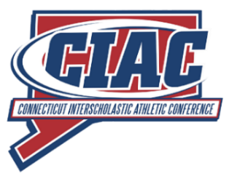
Pre-Tournament Reminders

To: CT Assignment Commissioners, Interpreters, and Officials
From: Dan Scavone, CMAA, CIAC Executive Staff, Director - CIAC Officials Association
Dave Grossman, CIAC Girls Tournament Assistant Director
Charley Harbach, CIAC and CT IAABO State Rules Interpreter, Board #7 Rules Interpreter

Re: Important Memo to be shared with and reviewed by all board assignment commissioners, interpreters, and officials.
In preparation for the CIAC boys' and girls' basketball tournaments, issues have come to our attention that need to be addressed before the tournament begins. Some issues have been observed during streamed games or in person and others have been reported by schools.

Issue #1: Uniforms worn by officials and teams

There have been instances of officials being out of uniform when officiating CIAC sanctioned games. Officials have been wearing college shirts in games. Officials have been wearing game shoes with white markings on them. Please refrain from wearing these items in games.

The rule book is clear as to the color of home uniforms. Rule 3-4-1c states the torso color shall be white for the home team and a contrasting dark color for the visiting team. There have been instances of the home team wearing colors other than white. Rule 10-6-4 states that the coach shall not permit a team member to wear an illegal uniform. The penalty, administered when discovered, is a technical foul, and only one technical foul is administered regardless of the number of offenders.

Issue #2: Mechanics

There have been many instances of officials NOT properly switching on every foul. This action not only demonstrates a lack of hustle and attention to detail, but it is also a disservice to the teams involved. Please, always properly switch on every foul. Officials should only use IAABO approved signals and mechanics in CIAC sanctioned games.

Issue #3: Pregame administration

During pregame warmups, all team members are considered bench personnel. Rule 10-5-1i states, in part, that bench personnel shall not dunk or attempt to dunk or stuff a dead ball. Therefore, the penalty for dunking during pregame warmups is a technical foul. Officials should NOT ignore this rule.

A general reminder regarding timeouts. With games being played that have playoff/tournament implications, it is incumbent upon officials to be aware of when coaches might want a timeout so that we are ready to grant them when requested. Please ensure that there is player control prior to granting any timeout.

